

Building Department
Flood Hazard: CHECK BEFORE YOU BUY

Flooding and other surface drainage problems can occur well away from a river, lake, or ocean. If you are looking at property, it is a good idea to CHECK out the possible flood hazard BEFORE you buy.
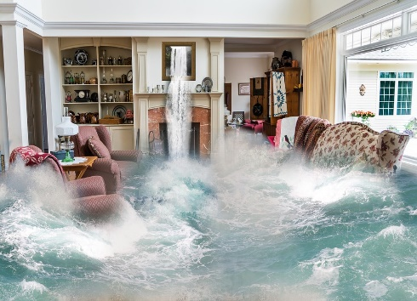
For these reasons:

✓ The force of moving water or waves can destroy a building.
✓ Slow-moving floodwaters can knock people off their feet or float a car.
✓ Even standing water can float a building, collapse basement walls, or buckle a concrete floor.
✓ Water-soaked contents, such as carpeting, clothing, furniture and mattresses, may have to be thrown out.
✓ Some items, such a photographs and heirlooms, may never be restored to their original condition.
✓ Floodwaters are not clean: floods carry mud, farm chemicals, road oil, & noxious substances that cause health hazards.
✓ The impact of a flood----cleaning up, making repairs, and the personal losses----can cause great stress to you, your family, and your finances.
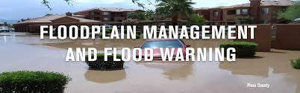
Floodplain Management Standards: To ensure that structures will be protected from flood damage, the Building Department regulates all development within the SFHA (Special Flood Hazard Area). Filling and similar projects require a permit and are prohibited in certain areas. Existing structures substantially damaged by flood that are located in the SFHA must be elevated 2ft above the BFE (Base Flood Elevation) BEFORE they are repaired.

Check for the Flood Hazard: Before committing yourself to buying property, please do the following:

✓ Consult with our office (228-273-3324) to inquire if the property is in a SFHA and what the Design Flood Elevation (DFE) is.
✓ Ask the Real Estate Agent if the property is within the SFHA, if it has ever been flooded, and if it is subject to any other hazards, such as sewer backup or subsidence.
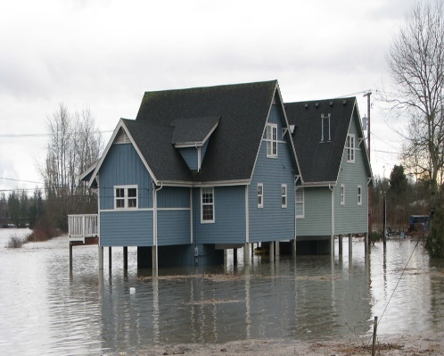
✓ Ask the Seller and the Neighbors if the property is within the SFHA, how long they have lived there, if the property has ever been flooded, and if it is subject to any other hazards.

Flood Protection: A structure can be protected from most flood hazards, sometimes at a relatively low cost. New construction and additions located within the SFHA must be elevated 2ft above the BFE. Existing structures can be protected from shallow floodwaters by regarding, berms, or floodwalls.

If the structure is located within the SFHA, flood insurance will be required by most mortgage lenders. Ask an Insurance Agent how much a flood insurance policy would cost. In most cases, there is a 30-day waiting period before flood insurance takes effect.

To ensure that accurate information is received when contacting the Building Department, please be prepared to provide the lot and block number, parcel number, legal description, or other identifying information when making your inquiry.

Vicki Watkins-CRS Coordinator

10383 Automall Pkwy ∙ PO Box 6519 D’Iberville, MS 39540-6519

Office: 228.273-3324
Website: www.diberville.ms.us
Email: vwatkins@diberville.ms.us

