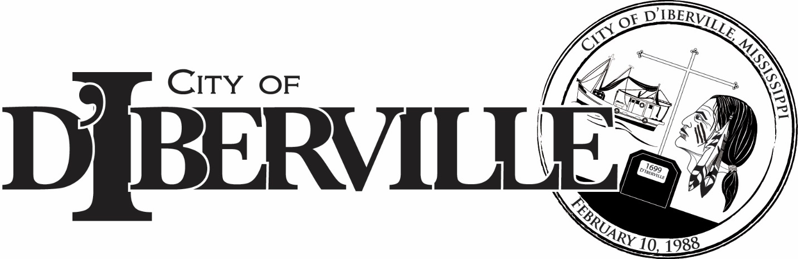
JOB POSTING…..Internal/External

POSITION: ELECTRICIAN DPT: PUBLIC WORKS
REPORTS TO: SUPERINTENDENT OF MAINTENANCE
SUMMARY OF THE JOB:
Responsible for troubleshooting, repairing and installation of electrical apparatus in the City of D’Iberville.
- Repairs electrical equipment and central operating equipment.
- Installs and repairs fluorescent industrial and general lighting fixtures and connections.
- Installs and maintains utility motors and appliances.
- Repairs electrical switches and relays
- Installs electrical call bells and buzzers
- Repairs and maintains electric motors.
- Inspects electrical and mechanical inspections for compliance with codes.
- Assists in the management and supervision of the maintenance and operations of City owned sewer lift stations.
- Checks and when necessary repairs generators and electrical hookups on the city water wells and tanks.
- Maintains electrical facilities and/or their structures.
- Responsible for general assignments and expected to plan and record details of each job and use judgement and initiative to carry it to completion without immediate supervision
- Is responsible for written daily activity reports and submits to the Public Works Department Administrative Assistant for proper documentation.

EDUCATION/EXPERIENCE/LICENSES:
- High school diploma or general education degree (GED)
- Current driver’s license and evidence of insurability
- 3 to 5 years of related experience and/or training
- Certification as an electrician preferred and if not certified, ability to obtain certification
CONTACT YOUR SUPERVISOR/DIRECTOR OR HUMAN RESOURCES FOR AN INTERNAL APPLICATION FORM. Internal / External applications will be taken Monday, January 26, 2026 through Friday, February 13, 2026. The City of D’Iberville is an equal opportunity employer.

