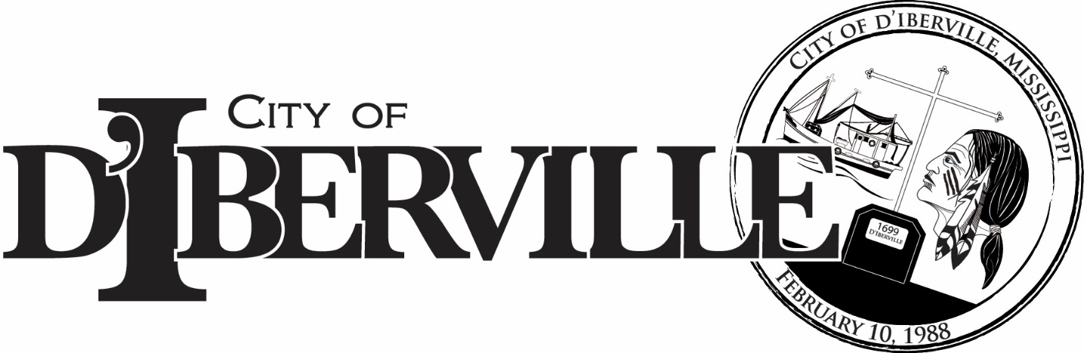
JOB POSTING…..INTERNAL AND EXTERNAL
POSITION: GENERAL SERVICES WORKER DPT: Parks and Rec
REPORTS TO: Matthew Toncrey, Crew Leader
SUMMARY OF THE JOB: Maintains grounds and areas along right-of-way of city, state and parks by performing the following duties:
- Sows grass seed or plants trees, shrubs, or flowers according to instructions and planned design of landscaped area.
- Applies herbicide or mulch to designated areas.
- Grubs and weeds around bushes, trees and flower beds.
- Trims hedges and prunes trees.
- Mows lawns.
- Picks up and burns or carts away paper and rubbish.
- Repairs and paints benches, tables and guardrails and assists in repair of roads, walks, buildings, and mechanical equipment.
- Any other duties as deemed necessary by the supervisor.
EDUCATION/EXPERIENCE/LICENSES:
- Current driver’s license and evidence of insurability
- One to three months related experience and/or training preferred
CONTACT YOUR SUPERVISOR/DIRECTOR OR HUMAN RESOURCES FOR AN INTERNAL APPLICATION FORM. Internal applications will be taken Friday, September 4, 2026, through Thursday, September 10, 2026 COB. The City of D’Iberville is an equal opportunity employer.

